Cybernetics Protector

SEQUENCE DIAGRAMS

Admin Login Sequence

Admin
frmLogin
BAL:clsLogin
DAL:clsSqlHelper
DB
1 : Enter UserId,Pwd()
2 : InsertData ()
3 : ExecuteNonQuery()

4 : ExecuteNonQuery()
5 : Response()
6 : Show Result()

Citizen

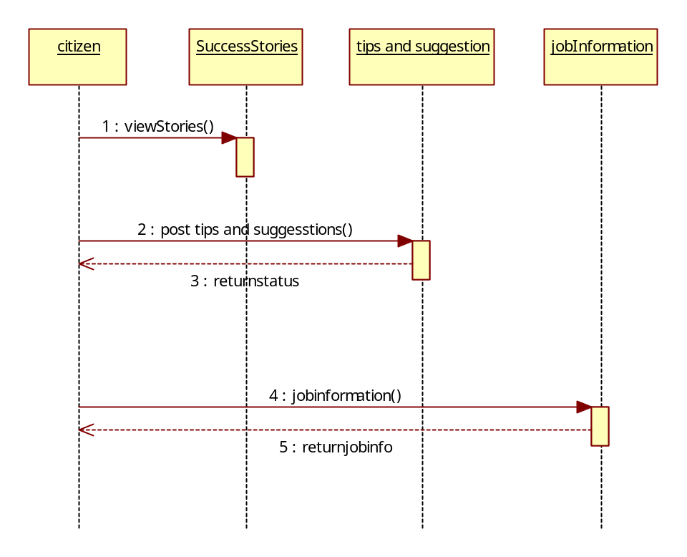

Admin Sequence To Accept Agency Request

Admin
frmAcceptAgency
Request
BAL:BusinessLayer
DAL:DAL.cs
DB
1 : Enter Companies Data()
2 : Insert Companies()
3 : ExecuteNonQuery()

4 : ExecuteNonQuery()
5 : Response()
6 : Show Result()

Admin Sequence To Add Case Details

Admin
frm AddCase
BAL:BusinessLayer

DAL:Dal.cs

DB
1 : Enter Policies Data()
2 : InsertPolicies()
3 : ExecuteNonQuery()
4 : ExecuteStoredProcedure()
5 : Response()
6 : Show Result()

Admin Sequence To Assign Case to Agency

Agent
frmassignCase
BAL:BusinessLayer

DAL:Dal.Cs

DataBase
1 : view Regd Customers()
2 : Accept Customers()
3 : ExecuteNonQuery()
4 : ExecuteStoredprocedure()
5 : Response()
6 : Show Result()

Agency Sequence To Add agent

Agency
frmAddagent
BAL:BusinessLayer

DAL:Dal.cs

DB
1 : Select Product()
2 : InsertData()
3 : ExecuteNonQuery()
4 : ExecuteNonQuery()
5 : Response()
6 : Show Result()

Agency To Assign case To Agent

Agency
frmAssign case To Agent
BAL:BusinessLayer

DALDal.cs

DB
1 : Enter Data()
2 : InsertUsers()
3 : ExecuteNonQuery()
4 : ExecuteNonQuery()
5 : Response()
6 : Show Result()

Cybernatics Protector Colloabration Diagrams

Admin Login

Admin
frmLogin
BAL:BusinessLayer

DAL:Dal.cs

DB
1 : Enter UserId,Pwd()
2 : Insert Data()
3 : ExecuteNonQuery()

4 : ExecuteNonQuery()
5 : Response()

Admin Sequence To Accept Agency Request

Admin
Frm Accept Agency
BAL:SusinessLayer
DAL:Dal.cs

DB
1 : Enter Policies Data()
2 : Insert Policies()
3 : ExecuteNonQuery()

4 : ExecuteNonQuery()
5 : Response()

Admin Sequence To Add Case Details

Admin
frm Case
Bal:BusinessLayer.cs
DAL:Dal.csr

DB
1 : Enter Companies Data()
2 : InsertCompanies()
3 : ExecuteNonQuery()

4 : ExecuteNonQuery()
5 : Response()

Agency Sequence To Add agent

Agent
frmAddAgent
BAL:BusinessLogic
DAL:Dal.cs

DataBase
1 : view Regd Customers()
2 : Accept Customers()

3 : ExecuteNonQuery()

5 : Response()
4 :ExecuteNonQuery()

Agency To Assign case To Agent

Agency
Frm assigncase
BAL:businessLogic
DAL:Dal.cs

DB
1 : Select Policy()
2 : Insert Customer Policy()
3 : ExecuteNonQuery()

4 : ExecuteNonQuery()
5 : Response()

Over View Use Case Diagram:

